

Redux thunk:-

In the redux this is part of redux this is used to maintain functionalities and storing values.

There are three major terms it can used to redux in our project.

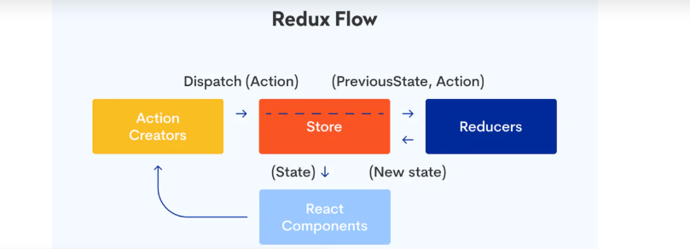

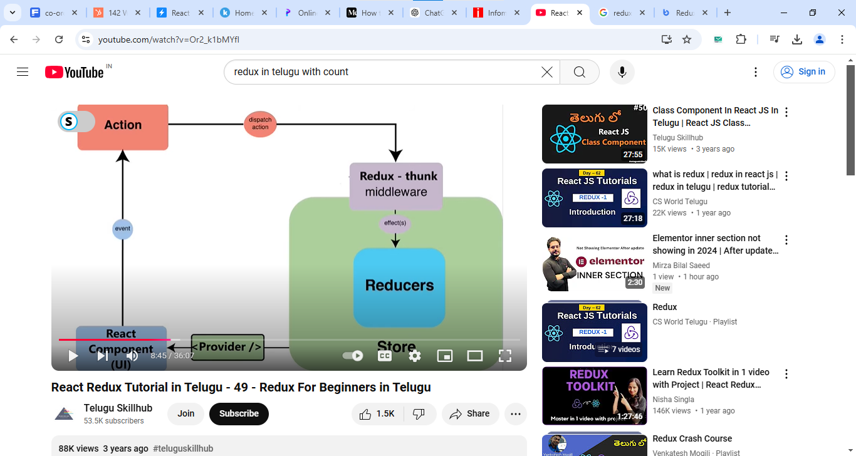

Store: we use the store to storing our states values.

Reducer: this is part of store in redux. Reducer is used to managing the store values which are storing values.

Actions: this maintains requests to give to reducers.

Ex:- If user make delete particular from store he rasies a request with action to give to reducers. Now reducers reacts takes request from action after accepts the reducer delete that value from store.

http://ec2-35-175-181-230.compute-1.amazonaws.com:8000/api/upload-csv

http://ec2-35-175-181-230.compute-1.amazonaws.com:8000/api/generate-synthetic

http://ec2-35-175-181-230.compute-1.amazonaws.com:8000/api/download/${syntheticFileName}

http://ec2-35-175-181-230.compute-1.amazonaws.com:8000/api/cleanup/${uploadedFileName}